Name – Davender Singh

Student ID – \*\*\*\*\*\*\*\*\*\*

Course – CCP555NSA

Professor – David Humphrey

1. Screenshot of the first time you ran Hadolint on your Dockerfile, showing any warnings or errors you had to correct:

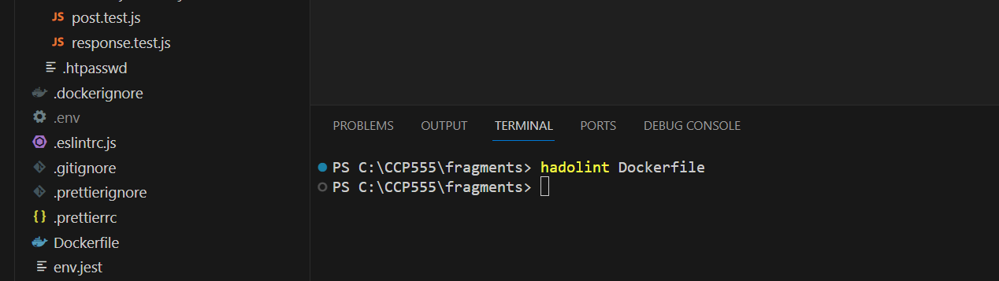

1. Screenshot of a successful CI workflow, showing your new Dockerfile Lint and Docker Hub jobs succeeding:

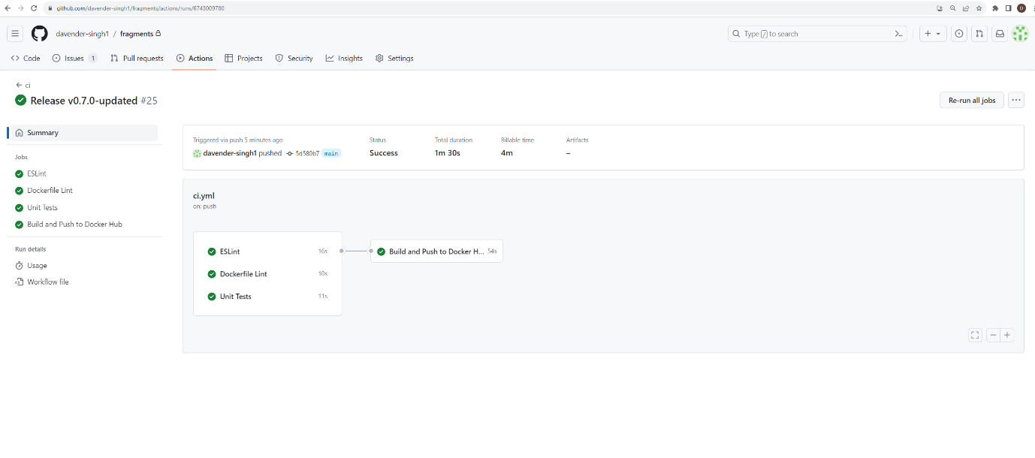

1. Screenshot of your main and latest Tags in Docker Hub, created by your GitHub Actions ci.yml workflow:

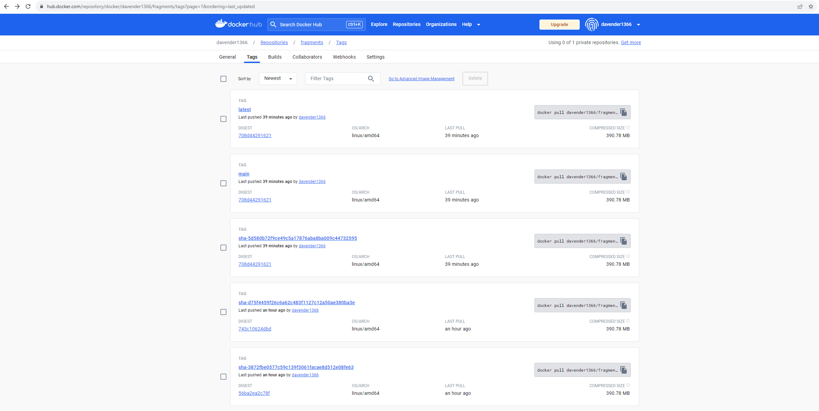

1. Screenshot of a successful CD workflow, showing your AWS login, build and push jobs succeeding:

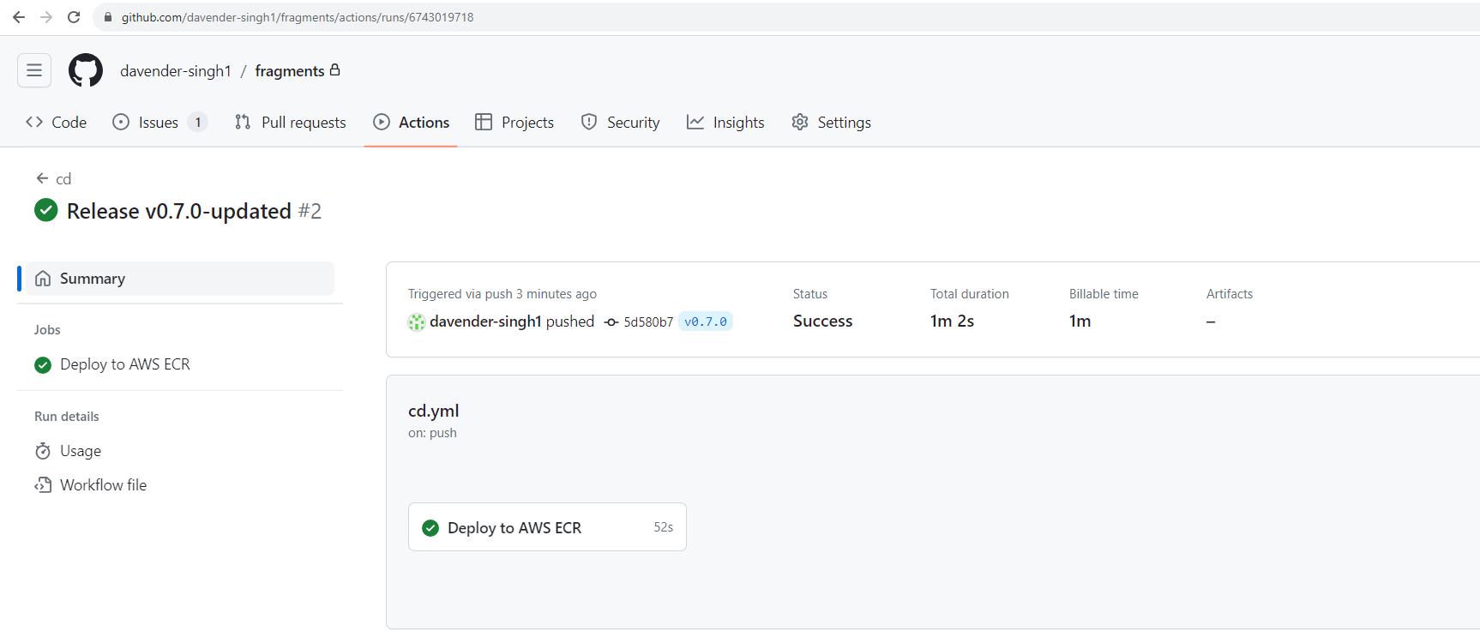

1. Screenshot of your Amazon Elastic Container Registry showing your fragments Image and tags, built via GitHub Actions:

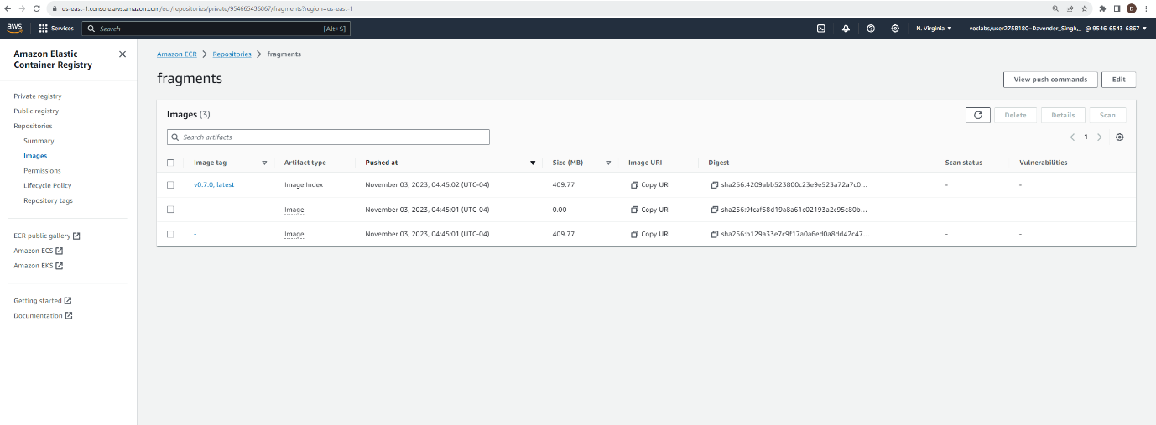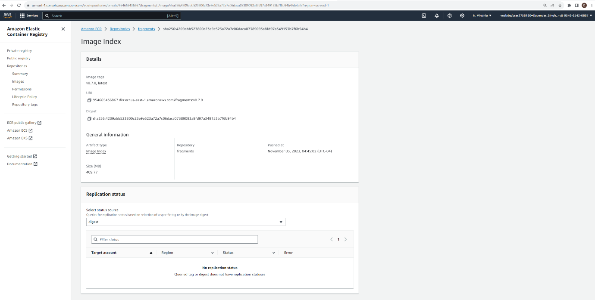

1. Screenshot of your local machine running the main image from Docker Hub, built and pushed by your GitHub Actions ci.yml workflow:

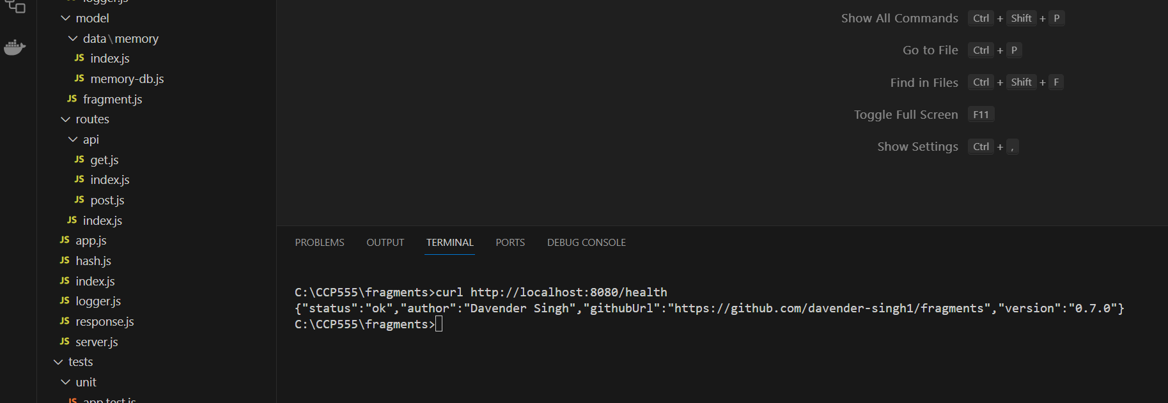

1. Screenshot of EC2 instance running the v0.7.0 image (or your latest version tag) your Amazon Elastic Container Registry and fragments repo, built and pushed by your GitHub Actions cd.yml workflow:

